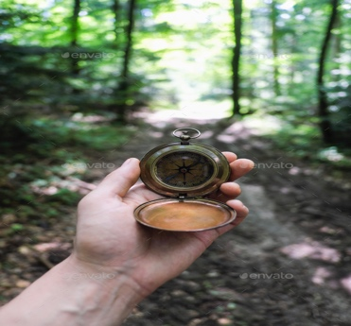 | The Great Outdoors  Project Information Page

In this exciting and interactive project, members will learn about many different skills that involve the outdoors. The sky is the limit! This project can be based around Outdoor Survival, Forestry, Astronomy, Wildlife, Ocean Excursions, or a variety of all things outdoors. Some activities may include packing a first aid or repair kit, building a shelter, studying constellations, trying a new outdoor activity, learning about wildlife making a fire and playing many exciting games that will help members learn about the wonderful world that surrounds them.
Project Completion Requirements (PCR)
- Attend The Great Outdoors Project Day on either May 5 or May 19, 2023
- Members can create a scrapbook if they choose, but this is not required and will not be credited as a project activity.
- Project (1) Page specific to Home Ec or Life Skill Projects. All activities should be documented.

4-H Year Completion
The following must be on display at the Club Achievement Day in order to complete the 4-H year
- Complete the PCR’s (Project Completion Requirements) as outlined above
- Complete a Communication (public speaking) Project
- Complete a Community Service Activity
- Complete an Agriculture Awareness Activity
- Complete the Member Documentation (4) pages found in your Portfolio or on the website

General Notes
- Leader Resources are available on the website or by contacting your 4-H Specialist
- Each month on the 15th (or thereby) a Provincial Newsletter is released with up-to-date information
- The Provincial Website www.pei4h.ca is regularly updated and the home of the Provincial Newsletter
- The second last Saturday in July each year is the deadline for Members to submit project work and portfolios to their 4-H Specialist for completion and to remain as a member in good standing. Only members in good standing can participate in summer exhibitions and be nominated /apply for special awards.

